**OPRATING SYSTEM**

Operating System Introduction: Operating Systems Objectives and functions, Computer System Architecture, OS Structure, OS Operations, Evolution of Operating Systems - Simple Batch, Multi programmed, time shared, Personal Computer, Parallel, Distributed Systems, Real-Time Systems, Special - Purpose Systems, Operating System services, user OS Interface, System Calls, Types of System Calls, System Programs, Operating System Design and Implementation, OS Structure, Virtual machines

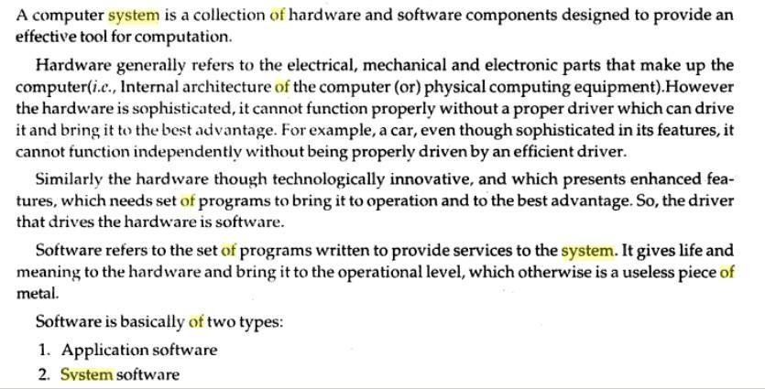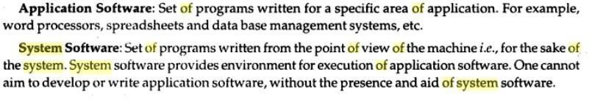

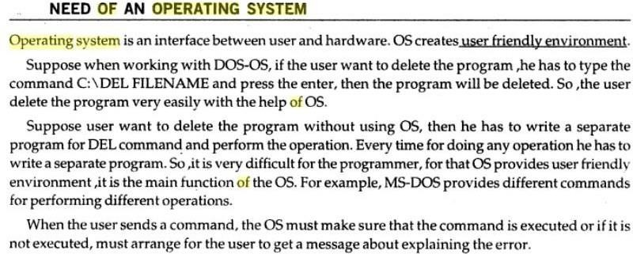

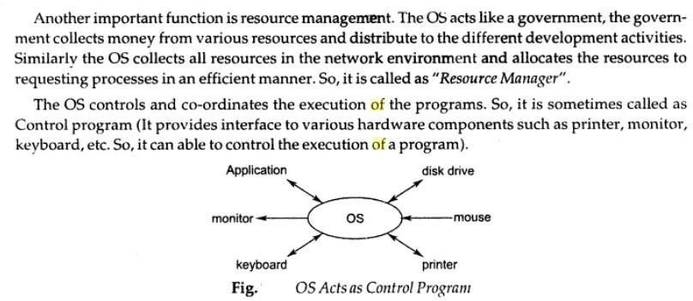

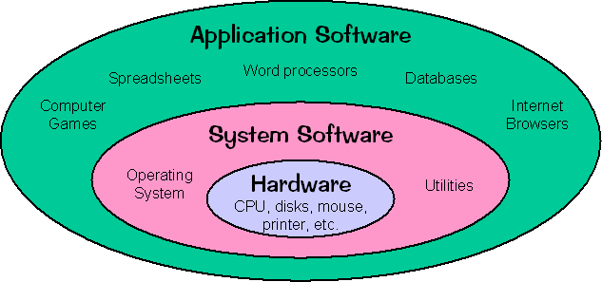

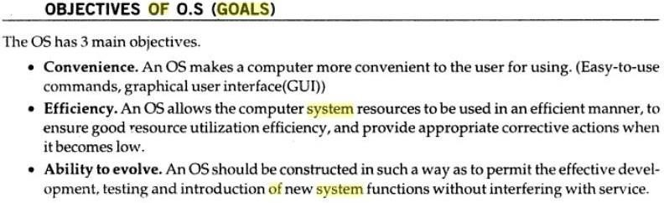

## Operating system performs the following functions:

1. Booting

Booting is a process of starting the computer operating system starts the computer to work. It checks the computer and makes it ready to work.

1. Memory Management

It is also an important function of operating system. The memory cannot be managed without operating system. Different programs and data execute in memory at one time. if there is no operating system, the programs may mix with each other. The system will not work properly.

1. Loading and Execution

A program is loaded in the memory before it can be executed. Operating system provides the facility to load programs in memory easily and then execute it.

1. Data security

Data is an important part of computer system. The operating system protects the data stored on the computer from illegal use, modification or deletion.

1. Disk Management

Operating system manages the disk space. It manages the stored files and folders in a proper way.

1. Process Management

CPU can perform one task at one time. if there are many tasks, operating system decides which task should get the CPU.

1. Device Controlling

operating system also controls all devices attached to computer. The hardware devices are controlled with the help of small software called device drivers..

1. Providing interface

It is used in order that user interface acts with a computer mutually. User interface controls how you input data and instruction and how information is displayed on screen. The operating system offers two types of the interface to the user:

1. Graphical-line interface: It interacts with of visual environment to communicate with the computer. It uses windows, icons, menus and other graphical objects to issues commands.
2. Command-line interface:it provides an interface to communicate with the computer by typing commands.

## Computer System Architecture

Computer system can be divided into four components Har dwar e – provides basic computing resources

CPU, memory, I/O devices, Operat ing system

Controls and coordinates use of hardware among various applications and users

Application programs – define the ways in which the system resources are used to solve the computing problems of the users

Word processors, compilers, web browsers, database systems, video games Users

People, machines, other computers Four Components of a Computer System

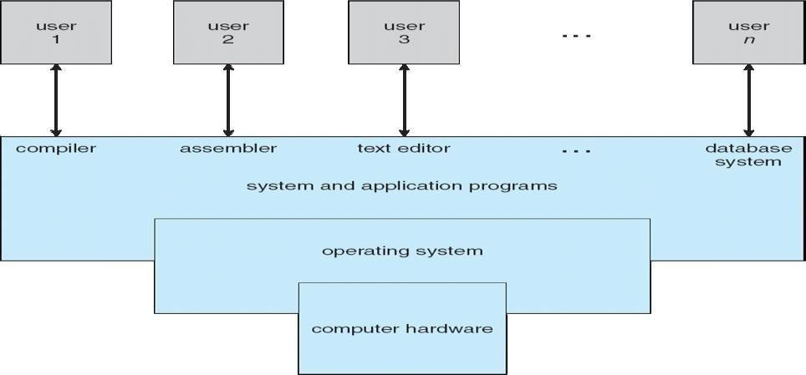

Computer architecture means construction/design of a computer. A computer system may be organized in different ways. Some computer systems have single processor and others have multiprocessors. So based on the processors used in computer systems, they are categorized into the following systems.

1. Single-processor system
2. Multiprocessor system
3. Clustered Systems:
4. Single-Processor Systems:

Some computers use only one processor such as microcomputers (or personal computers PCs). On a single-processor system, there is only one CPU that performs all the activities in the computer system. However, most of these systems have other special purpose processors, such as I/O processors that move data quickly among different components of the computers. These processors execute only a limited system programs and do not run the user program. Sometimes

they are managed by the operating system. Similarly, PCs contain a special purpose microprocessor in the keyboard, which converts the keystrokes into computer codes to be sent to the CPU. The use of special purpose microprocessors is common in microcomputer. But it does not mean that this system is multiprocessor. A system that has only one general-purpose CPU, is considered as single- processor system.

1. Multiprocessor Systems:

In multiprocessor system, two or more processors work together. In this system, multiple programs (more than one program) are executed on different processors at the same time. This type of processing is known as multiprocessing. Some operating systems have features of multiprocessing. UNIX is an example of multiprocessing operating system. Some versions of Microsoft Windows also support multiprocessing.

Multiprocessor system is also known as parallel system. Mostly the processors of multiprocessor system share the common system bus, clock, memory and peripheral devices. This system is very fast in data processing.

Types of Multiprocessor Systems:

The multiprocessor systems are further divided into two types; (i). Asymmetric multiprocessing system

(ii). Symmetric multiprocessing system

1. Asymmetric Multiprocessing System(AMS):

The multiprocessing system, in which each processor is assigned a specific task, is known as Asymmetric Multiprocessing System. For example, one processor is dedicated for handling user's requests, one processor is dedicated for running application program, and one processor is dedicated for running image processing and so on. In this system, one processor works as master processor, while other processors work as slave processors. The master processor controls the operations of system. It also schedules and distributes tasks among the slave processors. The slave processors perform the predefined tasks.

1. Symmetric Multiprocessing System(SMP):

The multiprocessing system, in which multiple processors work together on the same task, is known as Symmetric Multiprocessing System. In this system, each processor can perform all types of tasks. All processors are treated equally and no master-slave relationship exists between the processors.

For example, different processors in the system can communicate with each other. Similarly, an I/O can be processed on any processor. However, I/O must be controlled to ensure that the data reaches the appropriate processor. Because all the processors share the same memory, so the input data given to the processors and their results must be separately controlled. Today all modern operating systems including Windows and Linux provide support for SMP.

It must be noted that in the same computer system, the asymmetric multiprocessing and symmetric multiprocessing technique can be used through different operating systems.

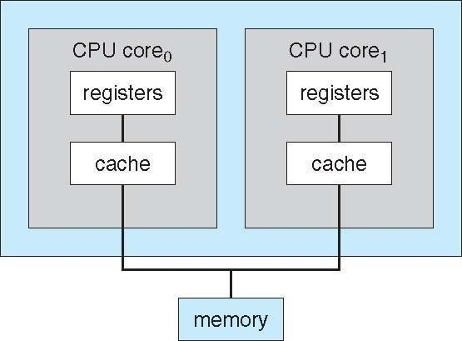

**A Dual-Core Design**

1. Clustered Systems:

Clustered system is another form of multiprocessor system. This system also contains multiple processors but it differs from multiprocessor system. The clustered system consists of two or more individual systems that are coupled together. In clustered system, individual systems (or clustered computers) share the same storage and are linked together ,via Local Area Network (LAN).

A layer of cluster [software](http://www.selfgrowth.com/software.html) runs on the cluster nodes. Each node can monitor one or more of the other nodes over the LAN. If the monitored machine fails due to some technical fault (or due to other reason), the monitoring machine can take ownership of its storage. The monitoring machine can also restart the applications that were running on the failed machine. The users of the applications see only an interruption of service.

Types of Clustered Systems:

Like multiprocessor systems, clustered system can also be of two types (i). Asymmetric Clustered System

(ii). Symmetric Clustered System

1. Asymmetric Clustered System:

In asymmetric clustered system, one machine is in hot-standby mode while the other

machine is running the application. The hot-standby host machine does nothing. It only monitors the active server. If the server fails, the hot-standby machine becomes the active server.

1. Symmetric Clustered System:

In symmetric clustered system, multiple hosts (machines) run the applications. They also monitor each other. This mode is more efficient than asymmetric system, because it uses all the available hardware. This mode is used only if more than one application be available to run.

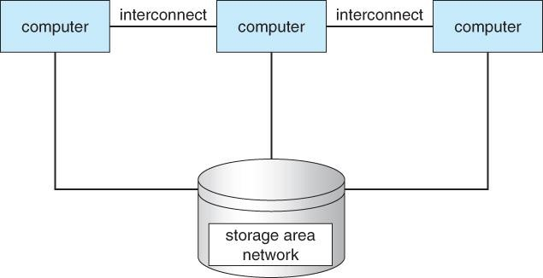

## Operating System – Structure Operating System Structure

**Multiprogramming** needed for efficiency

Single user cannot keep CPU and I/O devices busy at all times Multiprogramming organizes jobs (code and data) so CPU always has one to Execute A subset of total jobs in system is kept in memory

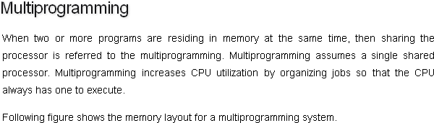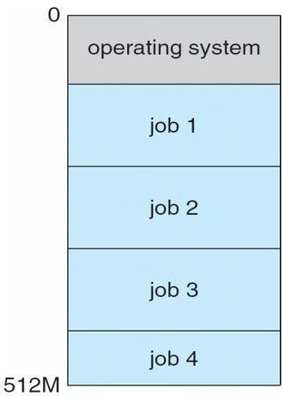

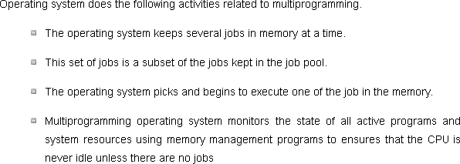

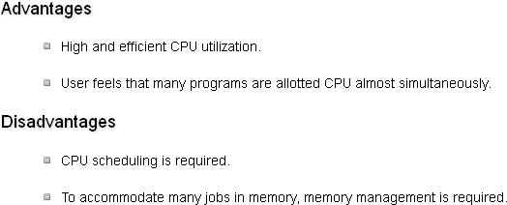

2) Multitasking

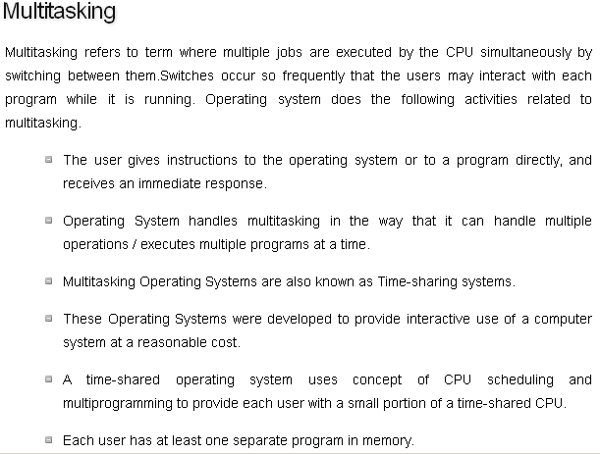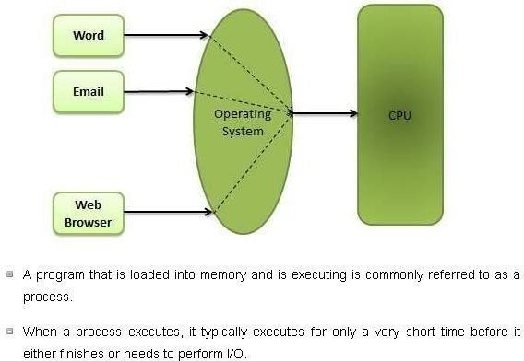

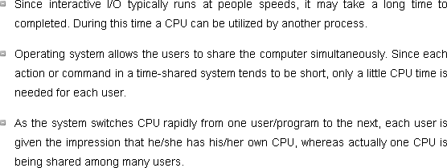

## Operating-system Operations

1. Dual-Mode Operation·

In order to ensure the proper execution of the operating system, we must be able to distinguish between the execution of operating-system code and user defined code. The approach taken by most computer systems is to provide hardware support that allows us to differentiate among various modes of execution.

At the very least we need two separate modes of operation.user mode and kernel mode.

A bit, called the mode bit is added to the hardware of the computer to indicate the current mode: kernel (0) or user (1).with the mode bit we are able to distinguish between a task that is executed on behalf of the operating system and one that is executed on behalf of the user, When

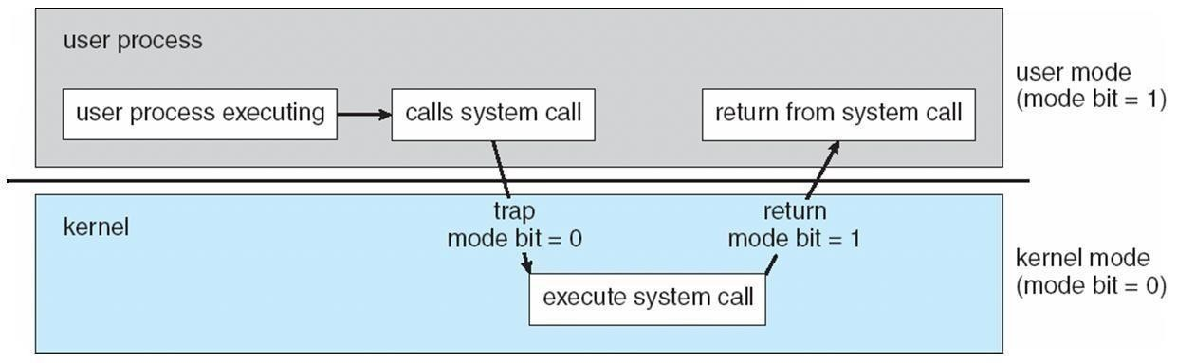

the computer system is executing on behalf of a user application, the system is in user mode. However, when a user application requests a service from the operating system (via a.. system call), it must transition from user to kernel mode to fulfill the request.

At system boot time, the hardware starts in kernel mode. The operating system is then loaded and starts user applications in user mode. Whenever a trap or interrupt occurs, the hardware switches from user mode to kernel mode (that is, changes the state of the mode bit to 0). Thus, whenever the operating system gains control of the computer, it is in kernel mode. The system always switches to user mode (by setting the mode bit to 1) before passing control to a user

program

The dual mode of operation provides us with the means for protecting the operating system from errant users-and errant users from one another. We accomplish this protection by designating some of the machine instructions that may cause harm as privileged instructions. the hardware allows privileged instructions to be executed only in kernel mode. If an attempt is made to execute a privileged instruction in user mode, the hardware does not execute the instruction but rather treats it as illegal and traps it to the operating system. The instruction to switch to kernel mode is an example of a privileged instruction. Some other examples include I/0 control timer management and interrupt management.

